The Common Few? To Be Inducted Into The
“Kansas Music Hall of Fame”
January 13, 2007

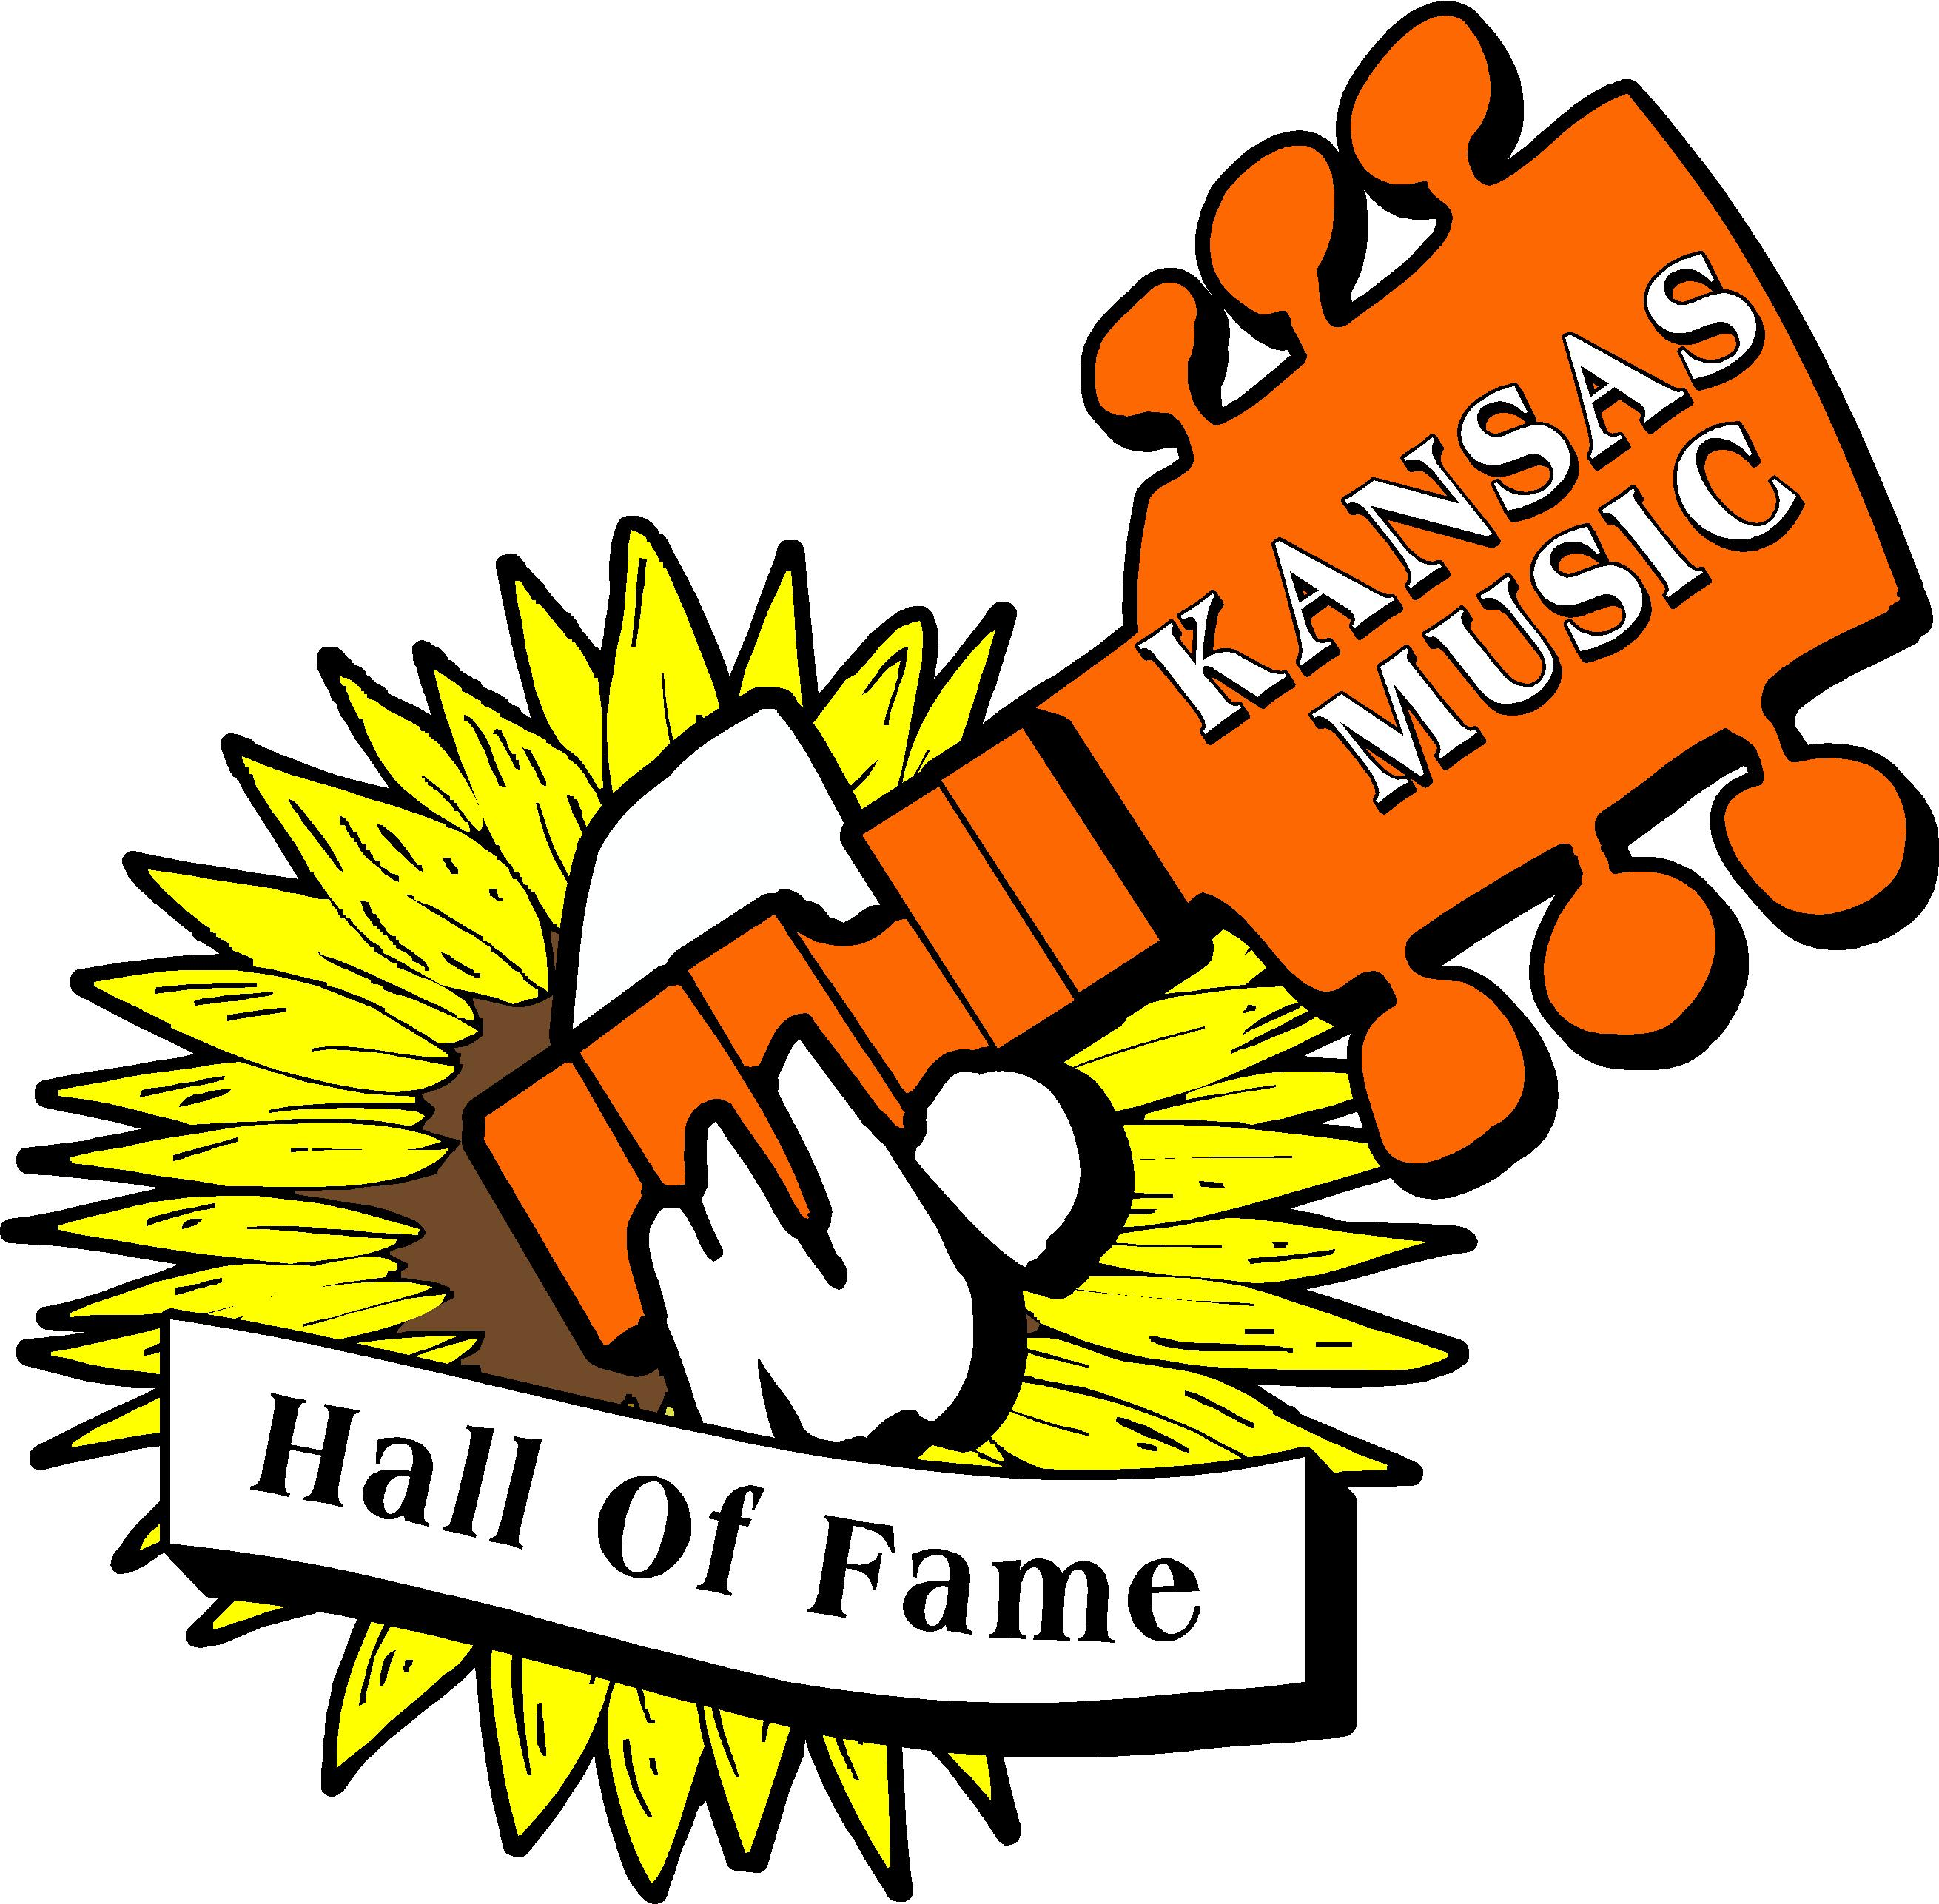
The Common Few?, a local garage band that started in 1964 and played through 1971 will be inducted into the Kansas Music Hall of Fame on January 13, 2007. The induction ceremony will be held in Lawrence, Kansas at Liberty Hall (formerly The Red Dog Inn).

The Kansas Music Hall of Fame was established in August, 2004, to recognize and honor performers and others who have made significant contributions to the musical history of the state of Kansas and the greater Kansas City metropolitan area.

The 2007 inductees are:
- Dawayne Bailey, Manhattan/Wichita
- The Blue Riddim Band, Lawrence/Kansas City
- The Common Few?, Chanute
- Marilyn Maye, Kansas City
- Martina McBride, Sharon
- The Rising Suns (2 versions), Topeka/Coffeyville
- (Fabulous) Silvertones, Kansas City
- Tide, Lawrence

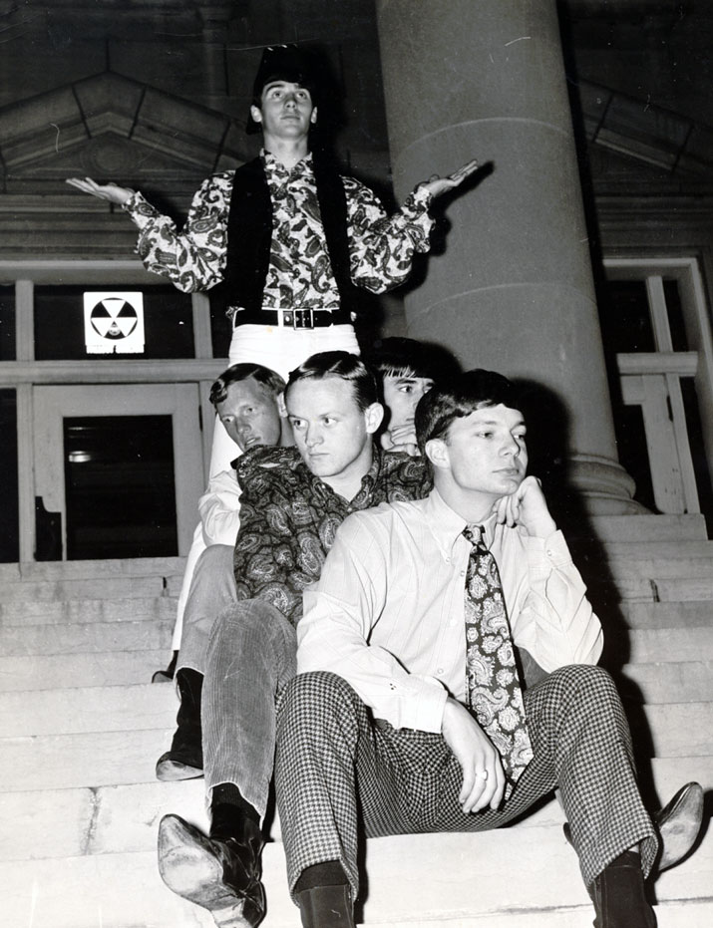
The members of The Common Few? from the 1966 graduating class of Chanute High School are Bob Crumrine and Mike King. From the 1967 graduating class are Darrel Brown, Mike DePriest, Ben Ennis, Eddie Ladd, Jeff Leverenz, and Robert Orr. From the 1970 graduating class is Cliff Wise. Joining the group while in college at Emporia State Teacher’s College were Gary Leitnaker of Ottawa, Jerry Myers of Independence, John Anderson of Iola and Pat Hair from Humboldt. The most recent member of the group since their reunion concert in November 2005 is Lex Fox, formerly of Cherryvale, Kansas. You can Log on to The Common Few? Web-site at www.thecommonfew.com to find out more past, present, and future information about the band and it’s members.

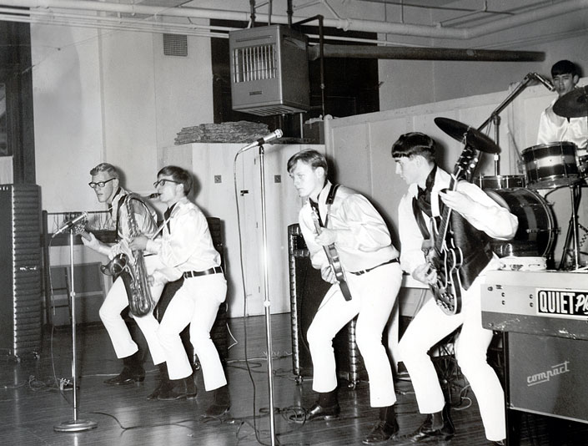
At the urging and tremendous support of Lion David Orr, “The Common Few?” reunited to play for the annual Lions Rock Hall of Fame benefit concert at the Chanute Memorial Auditorium in November 2005. Since that time the band has played for several benefit concerts for the Kansas Music Hall of Fame, and the Chanute Lions Club benefit dance during the Artist Alley weekend in Chanute last September.

“The Common Few?” will perform a set of songs during the induction ceremony on January 13, 2007 in Lawrence, Kansas along with 5 other bands. “The Common Few?” are also scheduled to play at the Lions Hall of Fame Concert at the Parsons Municipal Auditorium at Parsons Kansas on March 24, 2007.
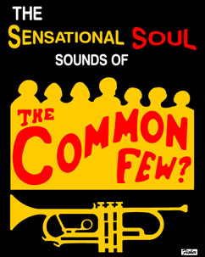

Tickets for the Kansas Music Hall of Fame induction ceremony can be purchased through Ticketmasters or by calling Liberty Hall in Lawrence, Kansas at 785-749-1912, or 785-749-1972. The Kansas Lions Hall of Fame Concert at Parsons, Kansas on March 28, 2007 will begin at 6:30pm, featuring three bands: The Common Few?, King Midas & The Mufflers, and The Lions Jam Band. Tickets can be purchased by calling 1-800-365-3999 or (620) 431-3490. Advanced ticket price is $30. Price at the door is $35.

